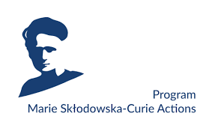

Expression of Interest
for hosting Marie Skłodowska – Curie Postdoctoral Fellow
at the University of Lodz

1. DEPARTMENT INTERESTED IN HOSTING POSTDOCTORAL FELLOWS
Faculty:
Department:
Contact person – potential Supervisor (name, e-mail address, position in organisation, phone number):
Website:

2. SCIENTIFIC AREA:
☐ Chemistry
☐ Economic Sciences
☐ Information Science and Engineering
☐ Environmental and Geosciences
☐ Life Sciences
☐ Mathematics
☐ Physics
☐ Social Sciences and Humanities

3. SHORT SUMMARY OF THE HOSTING DEPARTMENT (max. 1 page)
Activities and expertise:

Involvement in EU-funded research and training programmes/actions/projects:

Key research facilities:

Intersectoral secondments options
☐ YES ☐ NO

4. PROPOSED PROJECT TOPIC
Rough outline of project idea or key words (optional - max. 10 phrases)

5. VALID FOR THE FOLLOWING HORIZON-MSCA--PF CALL:
☐ 2023 ☐ 2024 ☐ 2025 ☐ 2026 ☐ 2027

MSCA Postdoctoral Fellowships are selected by EC on the basis of annual calls for proposals. Forthcoming and open calls for proposals can be found on the Funding & tender opportunities Portal of the European Commission

6. DO YOU CONSIDER THE NEED OF ON-SITE MEETING DURING THE APPLICATION PROCESS?
☐ YES ☐ NO

Within non-academic organizations (enterprises, hospitals, government institutions, cultural institutions, non-governmental organisations such as foundations, associations or other legal entities) – may be planned during the project provided they are in line with the Guide for applicants regulations of the corresponding call.

